**Pizza Sale SQL Queries**

1. **KPI’s**
2. **Total Revenue:**

select sum(total_price) as Total_revenue from pizza_sales

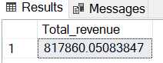

1. **Average order value:**

select sum(total_price) / count(distinct(order_id)) as avg_order_value from pizza_sales

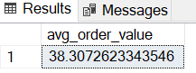

1. **Total Pizzas Sold:**

select sum(quantity) as total_pizzas_sold from pizza_sales;

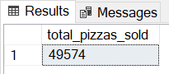

1. **Total Orders:**

select count(distinct(order_id)) as total_orders from pizza_sales;

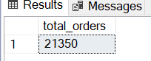

1. **Average Pizzas Per Order:**

select cast(cast(sum(quantity) as decimal(10,2)) /

cast(count(distinct(order_id)) as decimal(10,2)) as decimal(10,2)) as average_pizzas_per_order from pizza_sales;

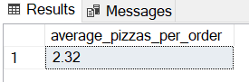

1. **For Charts:**
2. **Daily Trends:**

select datename(dw, order_date) as order_day, count(distinct(order_id)) as total_orders

from pizza_sales

group by DATENAME(dw, order_date)

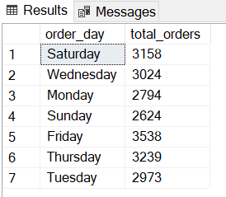

1. **Monthly Trends:**

select datename(month, order_date) as order_month, count(distinct(order_id)) as total_orders

from pizza_sales

group by datename(month, order_date)

order by total_orders desc

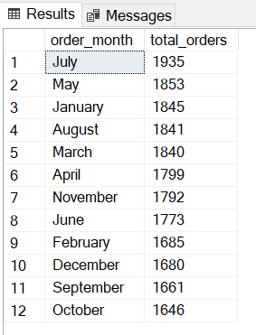

1. **Percentage overall sales by category:**

select pizza_category, sum(total_price) as total_sales,

sum(total_price) * 100 / (select sum(total_price) from pizza_sales) as percentage_of_sales

from pizza_sales

group by pizza_category

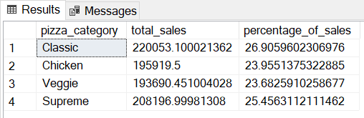

1. **Percentage of overall sales by pizza size:**

select pizza_size, cast(sum(total_price) * 100 / (select sum(total_price) from pizza_sales)

as decimal(10,2))

as percent_sold

from pizza_sales

group by pizza_size

order by percent_sold desc

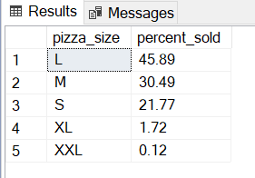

1. **Pizzas sold by category:**

select pizza_category, sum(quantity) as pizzas_sold,

cast(sum(total_price) * 100 / (select sum(total_price) from pizza_sales) as decimal(10,2)) as percentage_sold

from pizza_sales

group by pizza_category

order by pizzas_sold desc

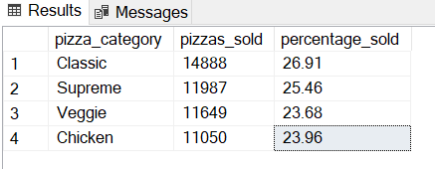

1. **Top 5 pizza names by revenue:**

select top 5 pizza_name, cast(sum(total_price) as decimal(10,2)) as total_revenue

from pizza_sales

group by pizza_name

order by total_revenue desc

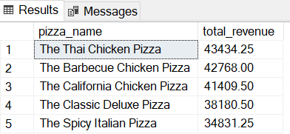

1. **Top 5 pizzas by quantity:**

select top 5 pizza_name, sum(quantity) as quantity from pizza_sales

group by pizza_name

order by quantity desc

